**MODULE FOR CANADARM2**

Authors: Justin Cabacungan, Alexander Tang, Nick Ribeiro

**CONTENTS**

INTRODUCTION. . . . . . . . . . . 3

QUICK FACTS. . . . . . . . . . . . . 4

IMAGES. . . . . . . . . . . . . . . . . . 6

TUTORIAL. . . . . . . . . . . . . . . . 7

REFERENCES. . . . . . . . . . . . . . 8

**INTRODUCTION**

The Canadarm2 is Canada's most famous robotic and technological achievement, made its space on November 13, 1981.  The robotic arm was instrumental in the construction of the ISS, berthing visiting vehicles to the ISS, assisting in the movement of supplies and space station maintenance.  This technology was successful that it was serve as an inspiration to most engineers and scientist to further improve their technologies and push the boundaries of science.

This web application will allow us to experience the advanced technology of the Canadarm. Users can freely move materials from one area to another on the ISS (International Space Station). Activities/Tasks of the app will allow users to understand the challenges of operating an equipment in microgravity.

**WHAT IS MICROGRAVITY?**

Microgravity is the condition in which people or objects appear to be weightless. The effects of microgravity can be seen when astronauts and objects float in space. Microgravity can be experienced in other ways, as well. "Micro-" means "very small," so microgravity refers to the condition where gravity seems to be very small.

**IS THERE GRAVITY ON SPACE?**

Gravity causes every object to pull every other object toward it. Some people think that there is no gravity in space. In fact, a small amount of gravity can be found everywhere in space. Gravity is what holds the moon in orbit around Earth. Gravity causes Earth to orbit the sun.

**CHALLENGE OF THE WEB APPLICATION:**

* The complexity of operating an equipment in microgravity
* Capture and attach a satellite for the ISS
* Deploy a Satellite into orbit

**QUICK FACTS**

* Canada Arm is a 17-metre-long**robotic arm**, and was extensively involved in the assembly of the orbiting laboratory.
* Each end has identical “hands” called Latching End Effectors.  These End Effectors use cables to firmly grasp objects in space, vehicles, and attach the arm to the ISS.
* 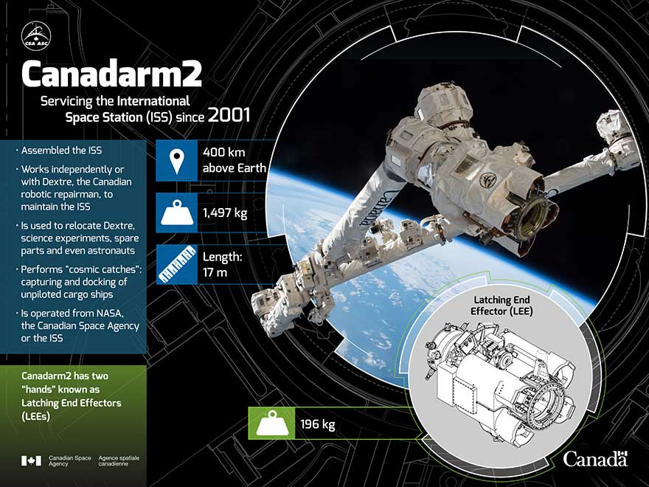Canada Arm’s specification, location, and functions:

Image source: Canadian Space Agency

* 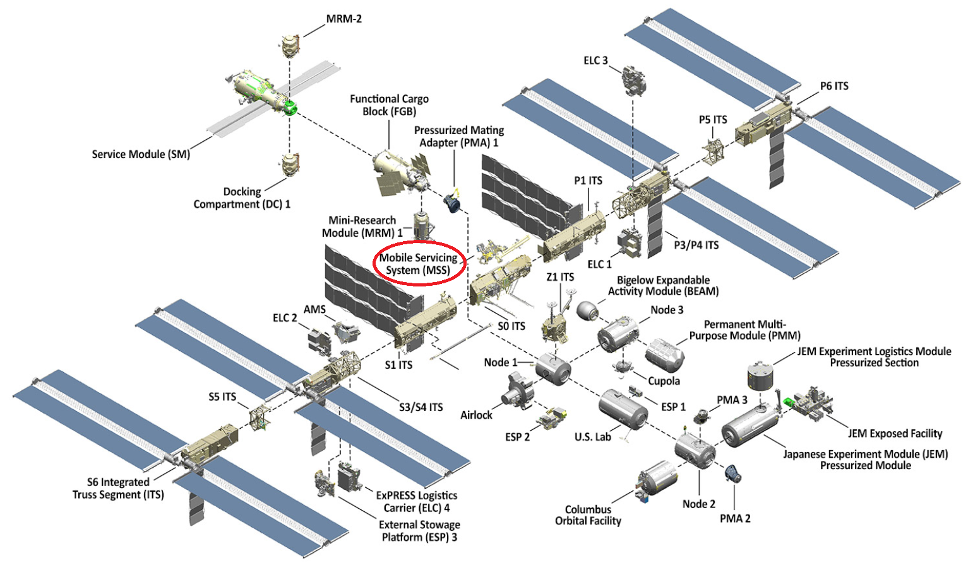Location of the robotic arm in the ISS (International Space Station) is in Mobile Service System

Image source: <https://www.nasa.gov/feature/facts-and-figures>

* Mission Overview of Canada Arm 2

**Technical Name:** Space Station Remote Manipulator System (SSRMS)

**Launch Date:** Canada Arm 2 was launched aboard Space Shuttle Endeavor on April. 19, 2001.

**Mission:** Assembling and maintaining the space station, and Capturing unpiloted resupply vehicles.

**Ownership:** Canadian Space Agency

**Built by:** MacDonald, Dettwiler, and Associates Ltd. in Brampton, Ontario

**Length:** 17 m

**Composition:** 19 Layers of high-strength carbon thermoplastic fibres.

**Degrees of Freedom:** Seven degrees of freedom, making it very similar to a human arm

Source: <http://www.asc-csa.gc.ca/eng/iss/canadarm2/data-sheet.asp>

* Along with Canadian astronaut Chris Hadfield, Canadarm2 was pictured on a coin, available in gold or silver, created in 2006 by the Royal Canadian Mint. The robotic arm was also featured on a 2011 stamp issued by Canada Post.

**IMAGES (WEBGL AND BLENDER)**

Images provided by: Nandu Vellal, and Nick Ribeiro

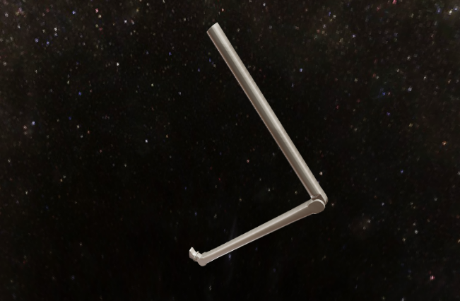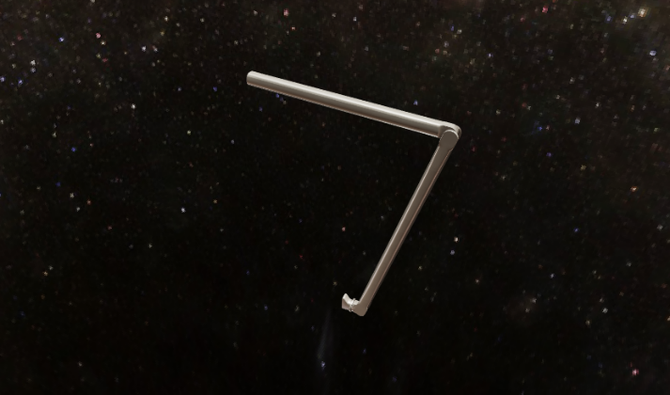

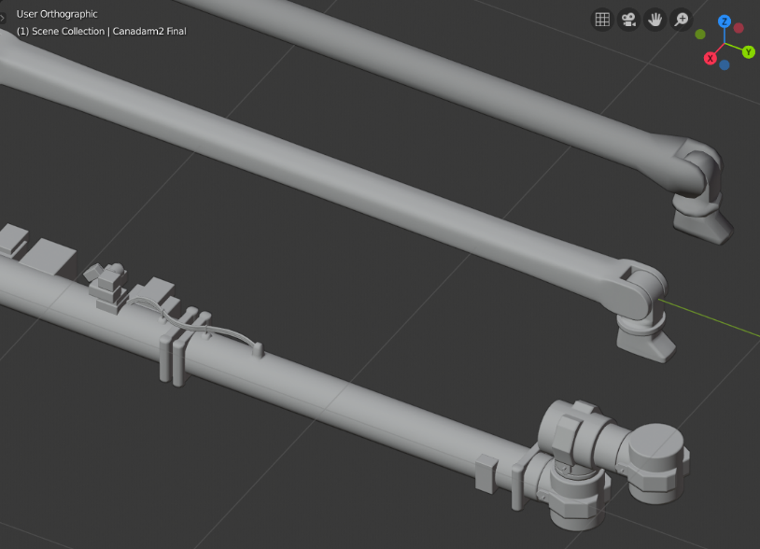

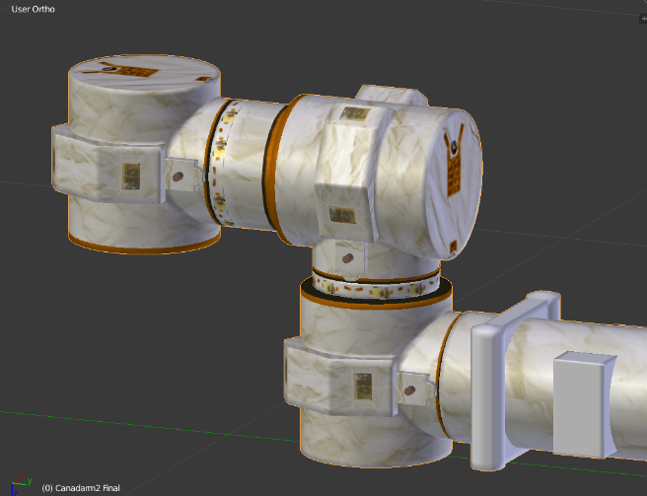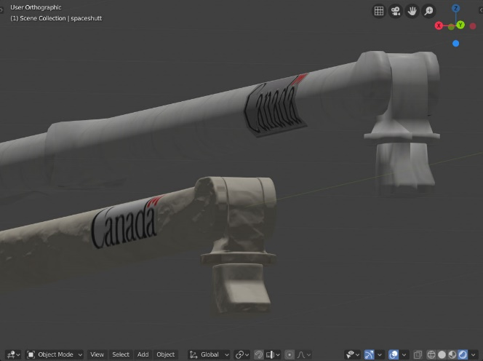

**TUTORIAL**

**REMINDER:** Once you open the page wait for a minute for it to assemble.

**STEP 1:** Use WASD keys on the keyboard along with up, down, right and left arrow keys to control the robot arm.

**STEP 2:**

**STEP 3:**

**STEP 4:**

**STEP 5:**

**REFERENCES**

* <https://www.nasa.gov/>
* <https://www.nasa.gov/sites/default/files/atoms/files/np-2015-05-022-jsc-iss-guide-2015-update-111015-508c.pdf>
* <http://www.asc-csa.gc.ca/eng/iss/canadarm2/default.asp>
* <http://www.asc-csa.gc.ca/eng/Default.asp>
* <https://www.nasa.gov/audience/forstudents/5-8/features/nasa-knows/what-is-microgravity-58.html>